**CAT(check and track) your internet usage**

* **Requirement and Specification**

**7조(구본호, 박광덕, 이주은)**

**<Abstract>**

"CAT" is a service that enables users to improve their Internet use by tracking and analyzing the Internet usage of users. It can be divided into three main parts: measuring the Internet usage of users, alerting them to Internet usage, and displaying a statistical analysis of the Internet usage.

* Measuring internet usage: By logging in when you start to use the Internet, you can record the start time, so that this work is not cumbersome by adding our product to the web launch page. Next, it automatically records the Internet usage time and the end time.
* Alerting them to Internet usage: Simple notification is performed when the user's Internet use time exceeds the time set by the user himself. By default, it displays the current usage in page title so that you can check the current usage without switching tabs.
* Displaying a statistical analysis of the Internet usage: The daily, weekly, and monthly Internet usage of users is compared to other groups and all members to statistically analyze and visualize them.

**<Customers>**

Basically all people who use internet are our beloved customers. There may be people who want to track their internet usage time, want to reduce their internet usage, or compare their internet usage with other people.

**<Competitive Landscape>**

Current #1 company is JiranSoft which make internet usage control program with about 100,000 downloads in Google Play and it is installed in most of computer in school. #2 company is Remente which make self improving application with about 100,000 downloads in Google Play.

Our product has the characteristics of both products. It also gives users an environment to track and analyze their Internet usage while controlling Internet usage.

Traditional Internet usage management programs have taken a strong approach to force the restriction of Internet use after certain conditions have passed. However, this approach could rather backfire. We therefore provide a small level of notification, such as alert, and we encourage users to improve their behavior by giving them the numbers and statistics on their usage.

For traditional self-tracking, self-improving apps, you must manually fill in your activity. However, our product records the starting and ending times of Internet use in a semiautomatic manner. Since it is optimized for Internet usage tracking, it also analyzes the share of usage of each site.

**<Features>**

|  |  |
| --- | --- |
| Registration | -Basic Information  User inputs username, password, age, occupation, sex.  -Alert setting  user sets up when, and for how often they want to get alert messages. |
| Login | User can log in. After that, user just do his/her job. |
| Measure internet usage | Website measures time starting from the time user logins to our website until the time user closes our website. The time will be shown on our website or browser tab momentarily. |
| Give alerts | According to user’s setting of alerts, the website will give pop-ups to give warnings to the users while they are logged-in to our website.. |
| Track | Track which websites user visits.  It will start to track when a user logged in. Tracking will stop when a user logged out or closed internet browser. |
| Show charts | -User’s internet usage  i) Based on user’s total internet usage time, the website will show internet usage time by day, week and month.  ii) More specifically, the website will show how long the user used each website.  -Overall users’ internet usage  Based on internet usage time of all users’, website will give histogram and show where among the bars the user of the website belongs. |

**<View>**

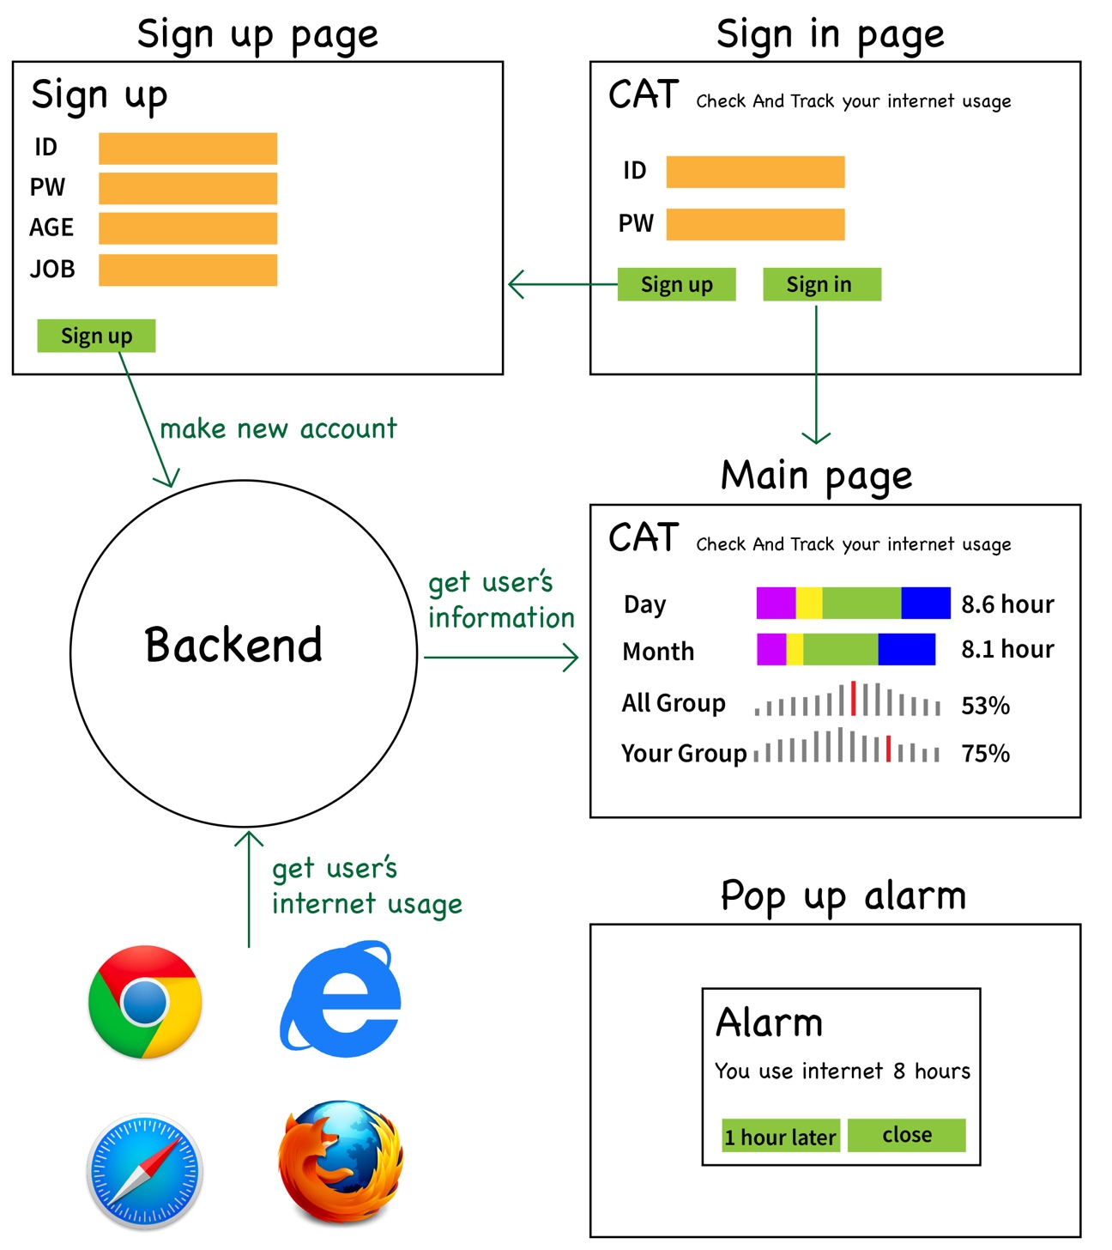

**<User Stories>**

* Story #1

User Type: As a heavy internet using user, I want to monitor my internet usage and reduce internet using time.

Scenario: Logs in to our website (Our website will be set as starting homepage)

-> Sets up alarm

-> Uses internet for several hours

-> Gets push alarms by our website

-> Returns to our website, and checks how long the user has been using internet this week.

-> User reduces the start of alarm to reduce internet using time

* Story #2

User Type: As a user, who wants to use time more wisely, I want to compare my internet usage with other people.

Scenario: Logs in to our website (Our website will be set as starting homepage)

-> Uses internet for several hours

-> Returns to our website, and checks how long the user has been using internet daily, weekly, monthly. Also user compares his internet usage time with other people.

->User can approximate how long he spends time on internet, and plans his day based on it.

* Story #3

User Type: As a marketer who wants to know, on which websites user stays for a long time.

Scenario: Collect subjects to the experiment and hand them out user IDs/ passwords

->Let the users use internet

->The marketer checks on which websites, users stayed for long time by checking their internet usage pattern on our website

-> The marketer can get a grasp on which website to pick to make an advertisement.

* Story #4

User Type: As a user, who is concerned about their children’s internet usage, want to check how their children uses internet.

Scenario: Logs in to our website (Our website will be set as starting homepage)

-> Let their children use internet for several hours

-> After their children finished using internet, parent returns to our website, and checks which websites their children visited during the day, and for how long they stayed.

-> User can get a grasp on their children’s internet usage pattern